Group GS16-61

University of Guelph

School of Engineering

50 Stone Road East

Guelph, Ontario, N1G 2W1

April 9, 2017

Dear Professor Hayward,

Please find enclosed Group 61’s Engineering Design 41X final report for your review and consideration.

Current methods of determining blood glucose levels are very invasive and can cause the users to experience discomfort and in some cases, medical emergencies. To solve this problem our team designed, built and tested a device that utilized infrared technology to determine blood glucose levels without having to insert a sensor within the user.

During the process of building and testing our prototype, we came across some very promising results. The prototype consisted of a 950nm LED as the infrared light source, a phototransistor as the receiver, an LM358 operational amplifier as a buffer, an Arduino as the microcontroller and a 2x16 LCD display screen that would be used to communicate glucose levels to the user of the device. During the testing phase, it was found that as the concentration of glucose within the sample being tested increased, the measured voltage by the phototransistor decreased, thus, proving that higher levels of glucose in a sample results in a larger absorption of infrared light. Although we did not have time to determine the glucose levels that result in a certain voltage value, the tests prove that a device of this nature can be implemented to non-invasively monitor blood glucose levels for individuals with diabetes. Please refer to the enclosed final report for more information about the reasoning, design components and testing process.

We thank you for all the support and knowledge you provided us throughout the duration of this project and we highly enjoyed our time time working with you on the Non-Invasive Glucose Monitor.

Sincerely,

Sarah Albernaz **

Parwaiz Amery **

Alexandra Campbell 

Chris Letwin **

Enclosure: ENGG*41X Design Final Report

|  |
| --- |
| universityofguelph.gif    University of Guelph  School *of* Engineering  **ENGG* 41X**  Advisor: Dr. Gordon Hayward  Final Report: Non-Invasive Blood Glucose Monitor |

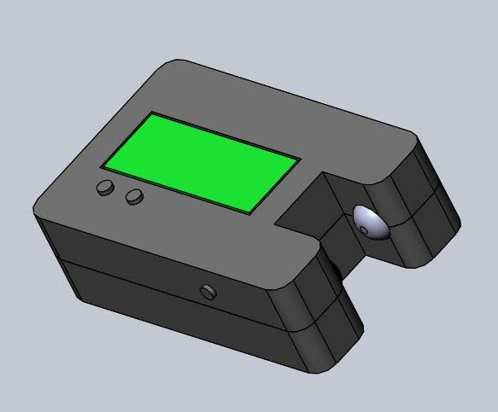

|  |
| --- |
| *Group GS16-61:*  *Sarah Albernaz (051313)*  *Parwaiz Amery (050186)*  *Alexandra Campbell (051424)*  *Chris Letwin (051539)* |

# **Executive Summary**

This document presents the Non-Invasive Blood Glucose Monitor, a blood glucose monitoring device that will utilize infrared technology to detect glucose levels without the user having to prick their finger or have a device inserted beneath their skin. The device uses a 950nm LED that shines a light through a sample towards a phototransistor that is sensitive to infrared light. Some of the infrared light will be absorbed by the glucose within the sample and the rest will be passed to the phototransistor where it will convert the detected light into a voltage value. This voltage value is then sent to the Arduino microcontroller where it is used to determine glucose concentrations and the result is presented on the 2x16 LCD display screen in an easy-to-read fashion. The device determines the glucose level by determining the amount of light that was absorbed by the sample. The voltage value that was sent into the Arduino will be compared to a voltage versus glucose concentration curve that will be used to determine the exact amount of glucose within the sample that would result in the voltage value. The device housing consists of a channel that has an LED and a phototransistor on either side where the user’s tissue will be placed for testing. Once the tissue is within the channel there is an ON/OFF button that the user can press to turn on the device. Once the glucose concentration is determined the device will make a sound to indicate that the test is complete and the LCD screen on the top of the device will display the results.

Despite not being able to test the device on a sample that would result in more interference such as human tissue, the data that was collected through testing the device with gelatin with predetermined levels of glucose within the range of 0g/L and 2g/L indicated that a device of this nature would be possible to implement and accurately determine blood glucose levels within a user’s sample.

The Non-Invasive Blood Glucose Monitor is expected to minimize the complications that can result from using the common invasive monitors on the market as well as be a more financially viable option for diabetics. As the completed design will be marketed at a price of $299.99, it is competitively priced to the average cost of $1,200 of the traditional poke and bleed monitors on the market.

The project was completed on time and within budget. It is recommended to invest into continued development of the device and release it on the market.

**Table of Contents**

**Executive Summary** **2**

**1.0 Introduction** **4**

**2.0 Problem Statement** **5**

**3.0 Objectives** **5**

**4.0 Background information** **6**

4.1 Typical Glucose Monitors (Poke Bleed Strip) 6

4.2 Implantable Monitors 8

4.3 Fluorescence Detection 9

4.4 Infrared Detection 10

**5.0 Design Methodology** **10**

5.1 Infrared Detection 10

5.2 Circuitry 11

5.3 Housing 11

**6.0 Prototype Testing** **12**

**7.0 Engineering Tools** **13**

**8.0 Social, Environmental, Economic, Health and Safety Impacts** **14**

8.1 Social Impact 14

8.2 Environmental Impact 14

8.3 Economic Impact 14

8.4 Health and Safety Considerations 14

**9.0 Timeline and Budget** **15**

9.1 Timeline 15

9.2 Equipment Costs 15

9.3 Consulting Costs 16

**10.0 Cost Analysis of Final Design** **17**

10.1 Fixed Costs 17

10.2 Variable Costs 17

10.3 Market Price 17

10.4 Operation and Maintenance 18

**11.0 Conclusion** **18**

**12.0 Recommendations** **19**

**13.0 Appendix** **19**

**14.0 References** **23**

# 

# 

# 

# 

# 

# 

# 

# 

# 

# 

# **1.0 Introduction**

Approximately 346 million people worldwide have some form of diabetes [4]. As diabetes does not have a cure, each of these people requires some sort of monitoring device that will inform them when their glucose levels fall outside of an optimal range. Most of the products on the market require the user to insert a device inside their body which could increase the chances of infection and more serious health issues. If there was a device on the market that could accurately measure an individual’s glucose levels that did not have to be implanted, the complications associated with using glucose monitors would decrease. Therefore, a non-invasive glucose monitor would greatly impact the lives of diabetics.

The goal of the design is to create a device that will provide an alternative to these invasive methods currently in use. The device will be able to accurately detect the user’s blood glucose concentration. The device consists of an LED and phototransistor which will be the main two components for sensing the glucose concentration, a screen for displaying the glucose concentration, and the appropriate circuitry required for the device to operate. The user will place the device around a small amount of skin, with the best measurements located on the ear lobe and in between the index finger and thumb as these are relatively easy to access, and press a button on the device to get the measurement.

# **2.0 Problem Statement**

Testing for diabetes requires invasive methods with the most common being pricking fingers to obtain a blood sample. This pricking of the finger not only causes discomfort to the user, but also creates the possibility for infection. The method of pricking a finger is also quite expensive as the lancets required for obtaining the blood sample cost approximately $100 per month based on the average amount of samples needed for appropriate management of diabetes [1]. Due to the relatively high cost of the lancets and the discomfort caused by piercing the user’s body, a non-invasive method for detecting blood glucose is beneficial.

# **3.0 Objectives**

The objective of this project is to design a non-invasive glucose monitor that can compete with glucose monitors currently on the market. Most of the current devices on the market require blood to be drawn so that testing can occur which causes physical discomfort to the user. Non-invasive alternatives have been designed but are not currently on the market as they are still in the testing phases of the design.

To achieve the objective of this project while also making the device competitive, the constraints identified in *Table 1* need to be adhered to. The constraints outlined in *Table 1* include meeting safety standards, specifically, following the guidelines from ISO 15197: 2013 - In vitro diagnostic test systems [5]. In this ISO standard, the appropriate level of accuracy for blood glucose monitors is outlined [5]. Another constraint of the non-invasive blood glucose monitor is that it must be a reliable device. This means that the glucose concentrations it displays must be accurate as they will be used to determine what treatment the user should administer. The device must also be non-invasive, meaning that there is no need for a blood sample to be provided for the device to determine the glucose concentration of the user. Finally, the device must be economically feasible, meaning that it should cost less than current devices so that it can compete on the market.

To make the device more competitive as well as make it more appealing to users, there are several criteria outlined in *Table 2* that should be optimized. For the device to be appealing to users, it should provide as little discomfort to the user as possible. Since the device is designed to test a small tissue sample such as the ear lobe or the tissue between the thumb and index finger, there should be enough space between the LED and phototransistor that the device does not pinch the user’s skin causing discomfort. The battery life of the device is also important to maximizing appeal. The battery should ideally last at least a week in order for the device to compete with current monitors as well as appeal to users so that they do not have to constantly change the battery. The size of the device should also be minimized so that it is easily portable and should be as visually appealing as possible to attract many people.

***Table 1:*** *Constraints of the Design*

|  |  |
| --- | --- |
| **Constraints** | **Description** |
| Meets safety standards | Follows guidelines from ISO 15197: 2013 - In vitro diagnostic test systems, which outlines how easily the user can read the results and how accurate the device should be [5]. |
| Reliability | The accuracy of readings must be equal to or better than the accuracy of current market devices. |
| Non-invasive | Device must be non-invasive to provide enhanced glucose measuring device. |
| Cost | Should be less than $1200/year to operate to compete with current market devices. |

***Table 2*:** *Criteria of Design*

|  |  |
| --- | --- |
| **Criteria** | **Description** |
| Comfort | Should be as comfortable as possible |
| Battery Life | Should last at least a week to compete with current market device |
| Size | Should be kept to a minimum for portability |
| Visually Appealing | Increases patient compliance |

# **4.0 Background information**

## **4.1 Typical Glucose Monitors (Poke Bleed Strip)**

*The information found in this section (4.1) has been reviewed and referenced in [1], unless otherwise stated.*

Typical glucose monitors function by pricking the user’s finger to obtain a drop of blood. This drop of blood is collected on a test strip and inserted into the glucose monitor, which then tells the user the amount of glucose in the blood. This type of monitoring is the most common form of diabetes management as the monitor is the most readily available monitor.

To use this type of monitor, test strips must be continuously purchased throughout the lifetime of the monitor. In Canada, over $500 million dollars were spent on these test strips in 2010. These test strips contain electrodes that are located on the plastic strip. One of the electrodes on the strip is there to ensure a sufficient amount of blood has been deposited on the strip while another electrode takes the glucose from the blood to the machine. Once these steps are complete, the device immediately begins testing and measuring the level of glucose in the blood.

Over time, typical blood glucose monitors have developed to very small machines that require a minimal amount of blood to get an accurate glucose measurement. These types of glucose monitors involve the use of enzymes to be able to get the accurate glucose reading that they require. Glucose oxidase is the most common enzyme used in blood glucose monitors. A series of chemical reactions are completed when glucose is introduced to the compounds present in the machine. One of the main compounds in the system is flavin adenine dinucleotide (FAD) which is there to accept electrons from glucose and become oxidized to continue the series of chemical reactions. During these reactions, hydrogen peroxide (H2O2) is produced, which becomes oxidized and reacts with the glucose molecules present in the blood at a proportional rate, so the amount can be detected.

An advantage of using this type of standard blood glucose monitor is that the main enzyme, glucose oxidase, is cheap and does not have large limitations in the preservation of the compound. Because of these advantages, when producing these types of machines, there are larger tolerances allowed without compromising the integrity of the enzyme which can be done by a change in pH or a change in temperature. Another advantage of using glucose oxidase as the primary enzyme in the glucose monitoring device is that it is less likely to deliver inaccurate glucose measurements compared to other enzymes used in similar devices. This is because it is less likely to be affected by the presence of non-glucose sugars and other molecules in the blood that can contribute to inaccurate measurements.

In addition to the enzymes used in typical glucose devices, mediators are also used to obtain glucose measurements from the blood. The purpose of the mediator is to react with the enzyme and begin a process of oxidation and redox reactions. These reactions help avoid the inaccuracies in readings due to interference from other molecules. When glucose oxidase is used as the enzyme in the device, dioxygen and hydrogen peroxide are most commonly used as the mediators. While using glucose oxidase as the main enzyme in the device has clear advantages, the use of dioxygen has many disadvantages. The main disadvantage of using dioxygen as the mediator is that the oxygen concentration in interstitial fluid is insufficient compared to the amount of glucose, which lessens the device’s ability to detect glucose. In order to use dioxygen safely in such a device, a membrane is added to the test strips to limit the amount of glucose compared to oxygen. Other enzymes that are sometimes used in typical blood glucose monitors are glucose dehydrogenase (GDH) which uses pyrroloquinoline quinone (PQQ) to convert the glucose present in the sample to gluconolactone. The monomers in the GDH help bind the PQQ to calcium ions present. The calcium ions activate the PQQ and lead to the oxidation of glucose for detection, similar to the method when using glucose oxidase as the enzyme. The disadvantage of using this GDH compared to glucose oxidase is that it is not as sensitive to the presence of glucose.

## **4.2 Implantable Monitors**

Many continuous glucose monitors on the market today require the insertion of a sensor beneath the skin that periodically gathers information about glucose levels and informs the user when their levels fall outside a safe range [4]. In comparison to typical glucose testing devices the implantable monitors greatly decrease the amount of complications that diabetics experience due to the constant observation of their levels [4].

The first real-time continuous glucose monitor to be approved by the FDA was the DexCom-7 [4]. This device uses a transcutaneous oxygen electrode implanted under the skin of the user [4]. The electrode is coated in glucose oxidase, an electro-chemical that reacts with glucose to generate a current signal. The signal is then sent back to the receiver and displayed to the user’s device [4]. This technology originally had a lifespan of 5 days, but it has since been adapted to have a lifespan of 7 days which is the longest lifespan of any similar devices on the market [4].

The most innovative implantable monitor that has been designed over the past few years is a monitor that uses a polymeric sensor connected to a microperfusion channel [8]. The electrode sensor is coated in a glucose oxidase sensitive layer and a porous silicon membrane that diffused glucose more accurately than other sensors thus, improving the accuracy of results [8]. While undergoing testing this type of monitor showed fast responses to changes in glucose levels and the quality of the results that were taken over its 7-day life span would remain stable [8].

## **4.3 Fluorescence Detection**

*The information found in this section (4.3) has been reviewed and referenced in [2], unless otherwise stated.*

Fluorescence-based glucose monitors are being developed as alternatives to typical glucose monitors because they provide several advantages over the typical poke-bleed type monitors [2]. While the poke-bleed type monitors are the most commonly used type of device for obtaining glucose measurements, fluorescence-based monitors are able to detect the presence of glucose without constantly drawing blood from the user. The fluorescence-based system obtains glucose measurements when light from a source strikes a molecule that has fluorescent properties. Once this light hits the molecule, an electron from the molecule will move up to a higher energy level. The molecule will then lose energy and emit light that will be observed by a receptor within the monitor [2].

One type of sensor that was commonly used in the past in these types of devices was concanavalin A (Con A) [2]. In experimentation, Con A bound to glucose when the Con A was attached to the wall of a dialysis fibre [2]. To achieve this binding, Con A, which was the acceptor, was paired with dextran with fluorescein isothiocyanate (FITC), which was the donor [2]. When glucose was present in the blood, the glucose would replace the dextran on the Con A [2]. As the FITC and the Con A separate, the FITC fluoresces and this fluorescence is what is detected to get a glucose measurement [2].

A more recent donor-acceptor pair being used in fluorescence-based glucose monitors is hexokinase/glucokinase. In this pair, the hexokinase is used to speed up the transfer of a phosphoryl group from ATP to the glucose. The glucose binds to the hexokinase and changes its shape. The subunits of hexokinase fluoresce at a wavelength of 300 nm with a measured maximum wavelength of 330 nm.

Other donor-acceptor pairs can be combined to achieve the same effect as hexokinase/glucokinase [2]. All of the donors in the pair require high frequency light to be able to detect the fluorescence throughout the lifetime of the probe which is usually about 2-3ns long [2]. Probes with longer lifetimes are beneficial because they can use a regular LED as the primary light source and they are able to filter most low-frequency fluorescence such as 60Hz which is the typical frequency of light [2].

## **4.4 Infrared Detection**

Another method that has been researched and developed to monitor blood glucose level is the use of infrared light. The general principle of infrared technology for this application is that light is transmitted across a tissue sample, typically, across the earlobe or between the index finger and thumb due to absence of bone and the small path length of these tissues [7]. Some of the transmitted light source is absorbed by glucose while the remaining light is received on the other side of the tissue by a receiving device that converts the signal into a value that can be processed to determine the blood glucose level [7].

The LED acts as the light source with a wavelength within the infrared region, between 900nm and 1550nm, and the photodiode placed on the other side of the sample acts as a receiver [7]. A low pass filter can be applied to reduce the high frequency noise at the output of photodiode [7]. There are factors that affect the absorption of infrared light such as the amount of blood in the tissue and the thickness of the tissue that is used [7]. The absorption of infrared light by proteins, lipids and urea that will affect the computation of glucose levels is different for varying wavelengths. Research has been conducted on the wavelengths of infrared light that would be best suited for glucose level observations and it has been determined that there are five wavelengths in the near and middle infrared range that would work. These wavelengths are 960 nm, 920 nm, 900 nm, 860 nm and 730 nm. Although all five wavelengths can be used to determine glucose levels the wavelength of infrared light that incurs the least amount of additional absorbance is a wavelength of 960nm [14].

# **5.0 Design Methodology**

The objective of the project was to design a blood glucose monitor that was non-invasive. The final design was implemented using infrared light. The completed device is designed to test glucose levels at the earlobe or skin between the index finger and thumb as there is no bone in these sections to interfere with the signal. The completed device will contain the circuitry responsible for measuring the voltage of the samples being tested and the housing which will consist of a battery, ON/OFF switch, and contain the circuitry within it.

## **5.1 Infrared Detection**

The infrared design is summarized in *Figure 1*. The design consists of one infrared LED with a wavelength of 950nm. The infrared LED used in the design was chosen to be 950nm as this was the wavelength that was proven to be least affected by proteins and other substances that would be found in tissue samples. The amount of light that passed through a sample was detected by the phototransistor and output a voltage. This voltage was then converted to a glucose concentration by using the voltage versus glucose concentration curve that was developed through testing.

## **5.2 Circuitry**

The circuit was designed with an Arduino providing power to the circuit. The overall circuit diagram can be seen in *Figure 1*. On the left side of the circuit, the 950nm infrared LED was connected to a resistor that minimized the current coming from the 3.3V port of the Arduino connected to the positive rail. On the right side of the circuit, a phototransistor was also connected to the positive rail of the breadboard powered by the 3.3V port of the Arduino. This phototransistor was then connected to an LM358 op-amp which was used to buffer the signal from the phototransistor before sending it to the Arduino. The LM358 op-amp was chosen for this circuit because it is suitable for use in low voltage applications. After receiving the signal, the Arduino was programmed, using the code seen in the *Appendix,* to determine whether or not the glucose concentration was high, low, or within an acceptable range. This level was then communicated to the user using the LCD display screen connected to the Arduino.

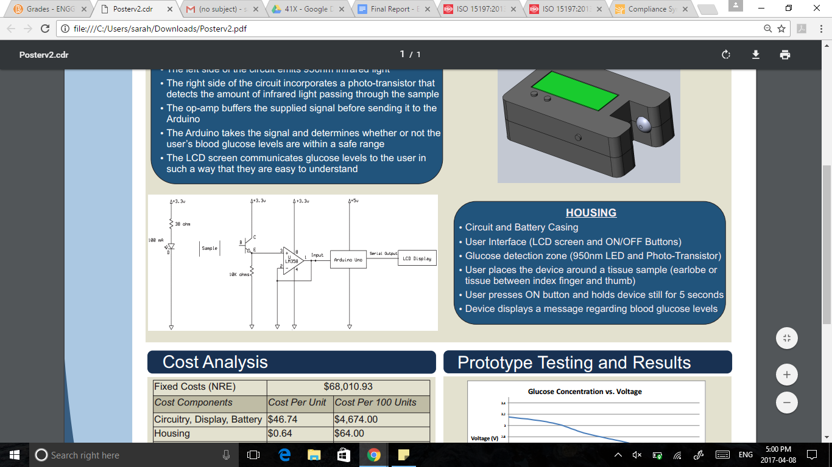

***Figure 1*:** *Schematic of Non-Invasive Glucose Monitor*

## **5.3 Housing**

The overall device was designed in SolidWorks and can be seen in *Figure 2*. The housing is designed to be small enough to make the device easily portable as well as relatively simple to use and maintain. To make the device portable, two 1.5V batteries are to be used for power. The housing is designed to make the batteries easily accessible through the bottom side of the housing as seen in the detailed drawings in the *Appendix*. The device is also designed to be easy to use by pressing the ON/OFF button to obtain a glucose measurement once the device is surrounding an appropriate area such as the earlobe or the skin between the thumb and the index finger. Once the button is pressed, the device takes the measurement and records it on the LCD screen located on the front side of the housing for the user to read. The infrared LED and the phototransistor are located on opposite sides of the glucose detection zone, while the earlobe or skin between the index finger and thumb is inserted in the zone.

**

***Figure 2*:** *Device Housing*

# **6.0 Prototype Testing**

Once the prototype was built, it was tested using gelatin containing predetermined glucose concentrations between 0g/L and 2g/L. As individuals with diabetes become hypoglycemic and hyperglycemic at blood glucose concentrations at 0.5g/L and 1.5g/L respectively [11], these samples would give an accurate depiction on whether the concept worked, as well as provide a graph that could be used to determine blood glucose concentrations when given a voltage value. Gelatin was used for the tests because it is a protein that is made by denaturing collagen [9] and as one of the main proteins in the skin is collagen [10], the use of gelatine in the testing process would provide the most accurate results. A small cube of each gelatin sample was placed between the LED and the phototransistor and the resultant voltage was read and recorded. Using the concentration and the voltage values, a plot of voltage versus the concentration of glucose was plotted and can be seen in *Figure 3*.

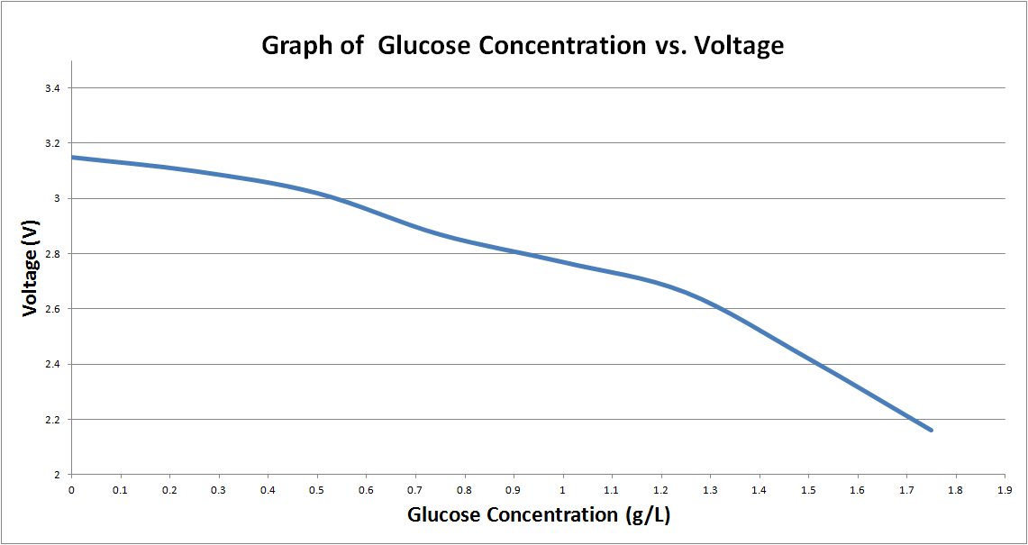

***Figure 3*:** *Testing Results*

# **7.0 Engineering Tools**

The design of the prototype will consist of electronics as described in *Table 3* with an illustrative diagram of these components located in *Figure 1*. The software used to for the design and testing of this device consisted of SolidWorks, Microsoft Excel, ExpressSCH and Arduino IDE Software. SolidWorks was used in the design of the device to model the housing. Microsoft Excel was used for creating the curve that showed the voltage versus the glucose concentration in the testing phase. ExpressSCH was used to draw the circuit used in the device and Arduino IDE Software was used to program the Arduino to display the results of the testing onto the LCD screen.

***Table 3:*** *List of electronics that will be used to build the prototype.*

|  |  |
| --- | --- |
| **Parts** | **Function** |
| Arduino Microcontroller | Process Data |
| Phototransistor | Infrared Receiver |
| Op-Amp | Amplify signal |
| LCD display | Display result |
| Resistor | - |
| LED lights | Emit infrared light |
| Low Pass Filter | Filtering the output noise |
| Bread Board | Building the electric circuit |

# **8.0 Social, Environmental, Economic, Health and Safety Impacts**

## 8.1 Social Impact

The social impact of this device is that glucose testing will be able to be done more discreetly as opposed to most current market designs. This is because the device will not look like the average glucose monitor due to it being non-invasive. This provides a social benefit to most users as they are able to test their blood glucose levels without drawing attention to the testing.

## 8.2 Environmental Impact

The environmental impact of this device is that test strips will no longer be required in this device. This decreases the amount of waste of the design which is beneficial to the environment. The poke-bleed type of glucose monitors also require the use of lancets to be able to prick the user’s finger to draw blood. These lancets will also not be needed in our design because the design is non-invasive. This also helps benefit the environment by decreasing the amount of waste.

## 8**.3 Economic Impact**

One of constraints of the non-invasive device is to cost less than $1200/year for operation. While the cost of manufacturing of the non-invasive device is expected to be more than current market devices, our device eliminates the need for test strips. Since the test strips account for the majority of the cost of operation for most devices currently on the market, our device will be able to cut that cost from our design.

## 8**.4 Health and Safety Considerations**

The health and safety considerations of our design include ensuring that the device adheres to standards for similar devices. These include standards regarding the level of accuracy and reliability of such a device outlined in the ISO 15197: 2013 - In vitro diagnostic test systems. Since the device can be used as a type of life-support tool, it must give accurate glucose readings and be reliable as the user will be using these readings to decide on their treatment.

# **9.0 Timeline and Budget**

## 9**.1 Timeline**

*Table 4* below contains the revised schedule updated with the dates outlined in the Winter 2017 41X course outline.

***Table 4****: Revised Schedule of Dates for 41X*

|  |  |  |  |
| --- | --- | --- | --- |
| Task | Start Date | End Date | Duration |
| *Interim Report* |  |  |  |
| Project Research -Literature Review | January 9 | January 27 | 18 days |
| Design Solution Revisions | January 28 | February 13 | 15 days |
| Interim Report Writing | February 6 | February 17 | 11 days |
| *Design Testing and Final Design Solution* | February 17 | March 3 | 14 days |
| *Final Report* |  |  |  |
| Building and Testing Final Prototype | March 4 | March 14 | 10 days |
| Final Report Writing | March 15 | April 9 | 24 days |
| *Poster Design* | March 27 | March 29 | 3 days |
| *Final Memo* | March 30 | April 9 | 10 days |

The project has now been completed on schedule with the submission of the final report as well as the final report memo. All tasks outlined in the schedule of dates were completed on time. The original schedule proposed at the start of the project was revised during the interim report to include updated Winter 2017 41X due dates as well as the addition of a prototype building and testing task. Prototype building and testing became a priority after it was clear that research alone was not enough to determine a final design solution. Once prototype testing was completed in mid-March and a proof of concept obtained, work began on the final report. Near the end of March, the majority of the final report was complete and a few days were spent adding the final report content to the poster design. Once the poster was completed, work resumed on the final report. On Wednesday, April 5th, a presentation was prepared for the upcoming poster presentation the next day. After the presentation on the 6th, the final report was completed over the next couple days and finished on April 8th. The final memo was then completely immediately afterward on the same day.

## 9**.2 Equipment Costs**

The final cost of the equipment for the project is outlined in *Table 5* below.

***Table 5*:** *Cost of equipment*

|  |  |  |  |
| --- | --- | --- | --- |
| **Name** | **Quantity** | **Cost** | **Total with Tax (CAD)** |
| Arduino Uno | 1 | $39.95 | $45.14 |
| Bread Board | 2 | $6.56 | $7.41 |
| LM 358 Op-amp | 1 | $0.11 | $0.12 |
| Display Screen | 1 | $10.95 | $12.37 |
| Infrared LED (950nm) and Phototransistor | 1 | $3.32 | $3.75 |
| **Total** |  |  | $68.79 |

The final cost of equipment ended up well below the expected cost of $326.69 from the interim report. This was mostly due to the elimination of shipping costs as parts were bought from a nearby Sayal electronics store as well as a reduction in quantity of each part.

## 9**.3 Consulting Costs**

The final cost for consulting can be seen in *Table 6*.

***Table 6:*** *Consulting costs*

|  |  |  |  |
| --- | --- | --- | --- |
| Engineer (Class A) | Hourly rate (CAD) [6] | Proposed Cost Including Overhead at 7 Hours/day for 60 days (CAD) | Final Cost upon Completion of Project(CAD) |
| Sarah Albernaz | $130 | $54,600 | $54,600 |
| Parwaiz Amery | $130 | $54,600 | $54,600 |
| Alexandra Campbell | $130 | $54,600 | $54,600 |
| Chris Letwin | $130 | $54,600 | $54,600 |
| Total | $520 | $218,400 | $218,400 |

*DISCLAIMER: Since this design project is for academic purposes, grades will be accepted instead of money.*

The project was completed within the budget set in the design proposal.

# 10.0 Cost Analysis of Final Design

## 10.1 Fixed Costs

The fixed costs associated with the final design are outlined in *Table 7* below.

***Table 7:*** *Fixed costs of final design*

|  |  |
| --- | --- |
| Item | Cost (CAD) |
| Consulting Cost of Design Development [6] | $218,400.00 |
| NRE-Cost of Integrated Circuit [18] | $68,010.93 |
| Total | $286 410.93 |

## 10.2 Variable Costs

*Table 8* below shows the variable costs associated with the final design.

***Table 8:*** *Variable costs of final design*

|  |  |
| --- | --- |
| Item | Cost Per Unit |
| Display | $12.37 |
| Battery | $1.99 |
| Infrared LED (950nm) and Phototransistor | $3.75 |
| Plastic Casing [17] | $0.64 |
| Integrated Circuit Chip [18] | $1.13 |
| Insurance (2% of sales) [19] | $5.99 |
| Total | $25.87 |

*DISCLAIMER: Assembly costs not included as price quotes from manufacturers could not be obtained.*

## 10.3 Market Price

Based on the $1,200/year operating costs of current blood-glucose monitors on the market in Canada, the target sale price of our device would be $299.99. This one time purchase is equal to three months of operating costs of current products after which the only cost is to replace batteries.Our product is also non-invasive which makes it more valuable than current invasive products on the market. The revenue per unit sold is $274.12 (before assembly costs) and therefore the break even point is 1045 units sold. The potential market for the device is an estimated 11 million diabetes and prediabetes prevalent cases in Canada, with that number predicted to increase to 13.9 million by 2026 [20]. It is therefore very likely that the breakeven point of 1045 units is made as this is only 0.0095% of the Canadian market, with huge potential for profit. Once successful in Canada, sale of the device could be expanded to the USA where there are an estimated 29.1 million diabetics and another 89 million with prediabetes [21].

## 10.4 Operation and Maintenance

The proposed device functions independently and the only additional materials needed for operation are batteries. Since the device will be powered using two AA batteries and a current draw of 100-160mA, the batteries should be able to operate for 7.5 to 42 hours depending on the type [15]. The device is only powered on for minutes at a time 2-8 times a day which means the batteries will last at minimum 50days assuming perfect discharge [16]. The cost of operation is therefore at most equal to two AA batteries every six weeks which is roughly $18per year. The device does not require any special maintenance and has no maintenance cost.

# **1**1**.0 Conclusion**

The main objectives of this project were to design and implement a non-invasive blood glucose monitor that would allow for the user to save money as well as decrease the likelihood of complications that can arise when using more traditional devices for monitoring blood glucose levels. After conducting research on the topic of non-invasive glucose monitoring it was determined that using infrared light could be used to noninvasively determine glucose levels within an individual.

The prototype was built and tested and it was observed that there was indeed a relationship between glucose concentrations and the absorbance of infrared light. As the glucose levels within a tested sample increased, the absorbance level also increased, thus creating a proof of concept and fulfilling the main goal of the design.

Lastly, an economic evaluation was conducted in regards to the project and it was determined that the cost of our design was well below the highly used poke and bleed strip method of determining glucose levels. As our design would be marketed at $299.99 and other devices have an operating cost of approximately $1,200 a month we have achieved our goal of creating a more financially viable device for monitoring blood glucose levels.

# **1**2**.0 Recommendations**

As there is now proof that the concept of using infrared light to monitor blood glucose levels works, the next step that should be taken is to apply for ethics approval to start testing the device on human samples. This is needed so the device can develop and improve enough to abide by the health and safety standards of Canada and take accurate measurements of glucose levels even when there are interferences. The proposed device is also cost-effective as determined in the cost analysis and is able to compete with current products on the market. Once the device has been approved by health and safety standards of Canada, it is recommended to put the final product on the market.

# **1**3**.0 Appendix**

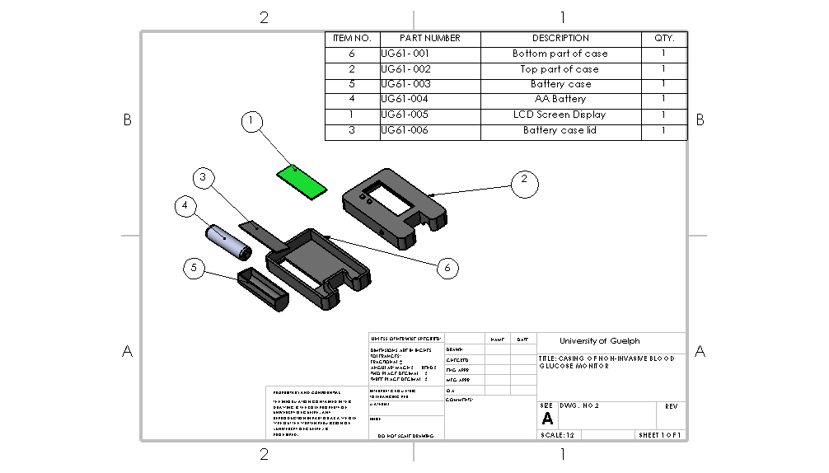***Figure 3***: *Breakdown of Housing Components*

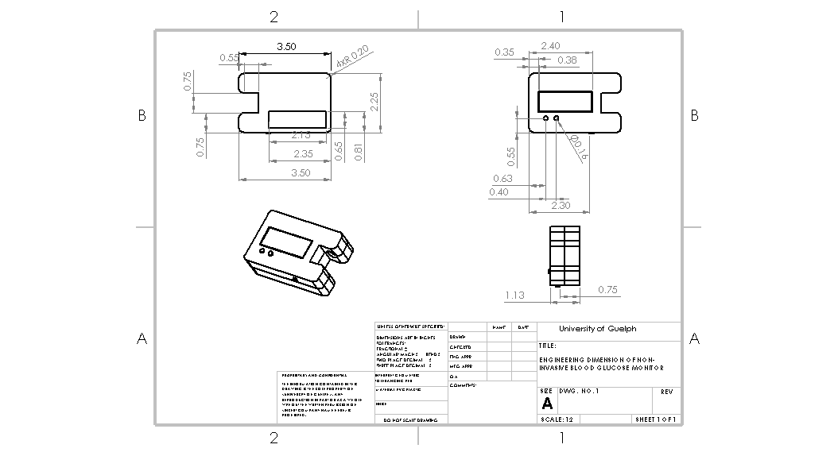***Figure 4*:** *Dimensions of Housing Components*

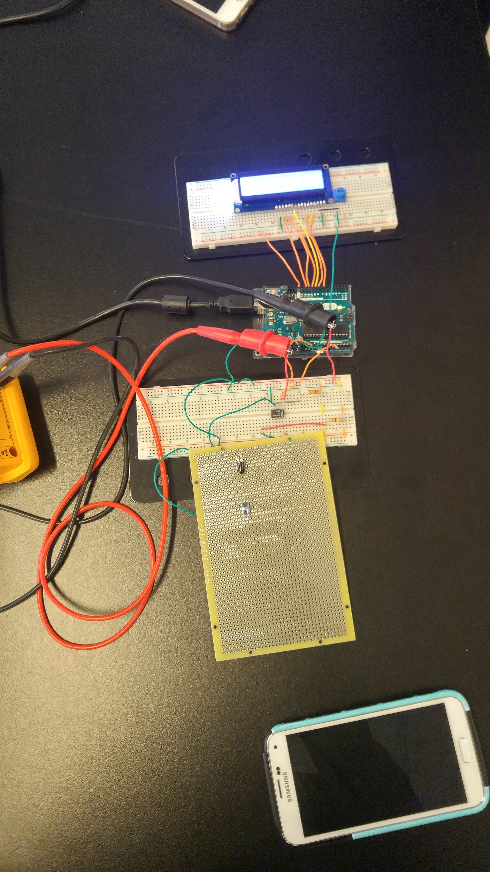

***Figure 5:*** Prototype

**Arduino Code:**

#include <LiquidCrystal.h>

// initialize the library with the numbers of the interface pins

LiquidCrystal lcd(7, 8, 9, 10, 11, 12);

void setup() {

// set up the LCD's number of columns and rows:

lcd.begin(16, 2);

}

// the loop routine runs over and over again forever:

void loop() {

lcd.clear();

lcd.setCursor(0, 0);

// read the input on analog pin 0:

int sensorValue = analogRead(A0);

// Convert the analog reading (which goes from 0 - 1023) to a voltage (0 - 5V):

float voltage = sensorValue * (5.0 / 1023.0);

voltage = voltage - 0.02;

// print out the value you read:

Serial.println(voltage, 3);

lcd.print("Voltage: ");

lcd.print(voltage);

lcd.setCursor(0, 1);

if(voltage < 0.5)

{

lcd.print("High glucose");

}

else if(1.5 < voltage)

{

lcd.print("Low glucose");

}

Else

{

lcd.print("Glucose is good!");

}

delay(1000);

}

# 14.0 References

[1] Vashist, Sandeep Kumar, Dan Zheng, Khalid Al-Rubeaan, John H.T. Luong, and Fwu-Shan Sheu. "Technology behind Commercial Devices for Blood Glucose Monitoring in Diabetes Management: A Review." *Analytica Chimica Acta* 702.10 (2011): 124-36. *ScienceDirect*. Elsevier. Web. 10 Feb. 2017. <<http://www.sciencedirect.com.subzero.lib.uoguelph.ca/science/article/pii/S0003267011009652?np=y&npKey=60b397d1824f66b08b146a8ee6d743bbe28717b8804e59018b1926e5c6c75d56>>.

[2] Pickup, John C., Faeiza Hussain, Nicholas D. Evans, Olaf J. Rolinkski, and David J.S. Birch. "Fluorescence-based Glucose Sensors." *Biosensors and Bioelectronics* 20.12 (2005): 2555-565. *ScienceDirect*. Elsevier, 15 June 2005. Web. 10 Feb. 2017. <http://www.sciencedirect.com/science/article/pii/S0956566304004579>.

[3] "How to Choose a Blood Glucose Monitor." *Health.com*. Health.com, 01 May 2008. Web. 10 Feb. 2017. <http://www.health.com/health/condition-article/0,,20188575,00.html>.

[4] Wang, Hui-Chen, and An-Rong Lee. "Recent Developments in Blood Glucose Sensors." *Journal of Food and Drug Analysis* 23.2 (2015): 191-200. Web. 17 Feb. 2017

[5] "ISO 15197:2013." *International Organization for Standardization*. N.p., n.d. Web. 03 Nov. 2016. <<https://www.iso.org/obp/ui/#iso:std:54976:en>>.

[6] "Engineering fee guideline," in *Ontario Society of Professional Engineers*, 2016. [Online]. Available: https://www.ospe.on.ca/engineering-fee-guideline. Accessed: Nov. 3, 2016.

[7] Khan, M. A. (n.d.). Non-invasive blood glucose monitoring using near-infrared spectroscopy. Retrieved February 15, 2017, from<http://www.edn.com/design/systems-design/4422840/Non-invasive-blood-glucose-monitoring-using-near-infrared-spectroscopy#comments>

[8] Matzeu, Giusy, Larisa Florea, and Dermot Diamond. "Advances in Wearable Chemical Sensor Design for Monitoring Biological Fluids." *Sensors & Actuators: B.Chemical* 211.Complete (2015): 403-18. Web. 17 Feb. 2017

[9] Chaplin, Martin. "Gelatin." *Gelatin*. N.p., n.d. Web. 07 Apr. 2017. <http://www1.lsbu.ac.uk/water/gelatin.html>.

[10] Haratake, Akinori, Daisuke Watase, Shuichi Setoguchi, Nami Nagata-Akaho, Kazuhisa Matsunaga, and Jiro Takata. "Effect of Orally Ingested Diosgenin into Diet on Skin Collagen Content in a Low Collagen Skin Mouse Model and Its Mechanism of Action."*Life Sciences* 124 (2017): 77-82. *ScienceDirect*. Elsevier. Web. 07 Apr. 2017. <<http://www.sciencedirect.com.subzero.lib.uoguelph.ca/science/article/pii/S0024320517300693>>.

[11] Arnold, Marilynn. “Hyperglycemia and Hypoglycemia.” *American Dietetic Guide to Diabetes (2005):* 128-135. Web. 07 Apr. 2017. <https://books.google.ca/books?hl=en&lr=&id=ZaYc479cIY0C&oi=fnd&pg=PA128&dq=hypoglycemia+and+hyperglycemia&ots=CKqLgRlrvl&sig=5bvjONctxaggoiHCoknxXDewOTs#v=onepage&q&f=false>

[14] Zeller H, Novak P, Landgraf R. “Blood Glucose Measurement By Infrared Spectroscopy.” (1989). Web. 07 Apr. 2017 <<https://www.ncbi.nlm.nih.gov/pubmed/2707907>>

[15] "Battery selection for cameras, radios, flashlights -- The best economy for you." *Battery selection for cameras, radios, flashlights -- The best economy for you*. N.p., n.d. Web. 07 Apr. 2017. <<http://www.allaboutbatteries.com/index.html>>.

[16] "Blood sugar testing: Why, when and how." *Mayo Clinic*. N.p., 20 Dec. 2014. Web. 07 Apr. 2017. <<http://www.mayoclinic.org/diseases-conditions/diabetes/in-depth/blood-sugar/art-20046628>>

[17]"Cost Estimator." *Injection Molding Cost Estimator*. N.p., n.d. Web. 07 Apr. 2017. <<http://www.custompartnet.com/estimate/injection-molding/>>

[18] PeopleVine, Sigenics Via. "Custom ASIC Cost Calculator." *SIGENICS*. N.p., n.d. Web. 07 Apr. 2017. <<http://www.sigenics.com/page/Asic-Cost-Calculator>>

[19] "Medical equipment and pharmaceutical products insurance." *SADLER*. N.p., n.d. Web. 07 Apr. 2017. <<https://www.products-liability-insurance.com/medical-equipment-products/>>

[20] "Diabetes in Canada." *Canadian Diabetes Association*. Diabetes Canada, Oct. 2016. Web. 08 Apr. 2017. <<https://www.diabetes.ca/getmedia/513a0f6c-b1c9-4e56-a77c-6a492bf7350f/diabetes-charter-backgrounder-national-english.pdf.aspx>>

[21] "2014 National Diabetes Statistics Report." *Centers for Disease Control and Prevention*. Centers for Disease Control and Prevention, 15 May 2015. Web. 08 Apr. 2017. <<https://www.cdc.gov/diabetes/data/statistics/2014statisticsreport.html>>

|  |
| --- |
|  |